**FINDING TIME COMPLEXITY OF ALGORITHUMS**

**NAME: P JAYAPRADHA**

**ROLL NO: 230701130**

**Problem 1: Finding Complexity using Counter Method**

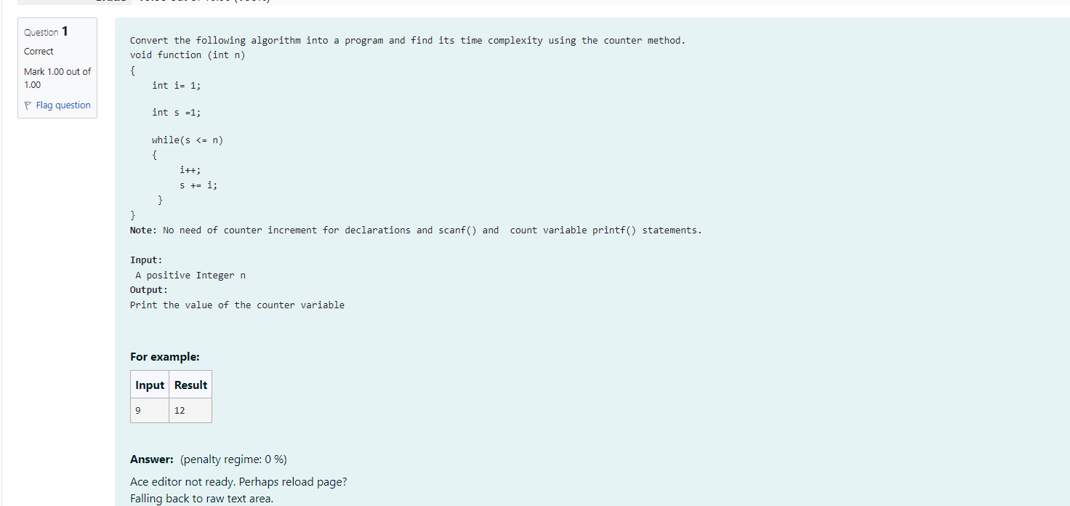

**Code**

#include <stdio.h>

int main()

{

int n,count=0,i=1,s=1;

scanf("%d",&n);

count++;

count++;

while (s<=n)

{

count++;

i++;

count++;

s=s+i;

count++;

}

count++;

printf("%d",count);

}

**OUTPUT**

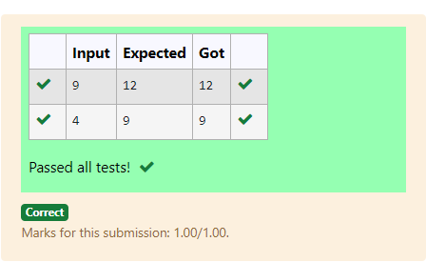

## Problem 2: Finding Complexity using Counter method

## 

## CODE

## #include<stdio.h>

## int main()

## {

## int n,count=0;

## scanf("%d",&n);

## if(n==1)

## {

## count++;

## printf("*");

## count++;

## }

## else

## {

## count++;

## for(int i=1; i<=n; i++)

## {

## count++;

## for(int j=1; j<=n; j++)

## {

## count++;

## count++;

## count++;

## break;

## }

## count++;

## }

## count++;

## }

## printf("%d",count);

## }

**OUTPUT**

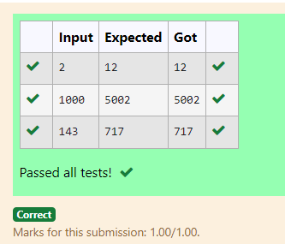

**Problem 3: Finding Complexity using Counter Method**

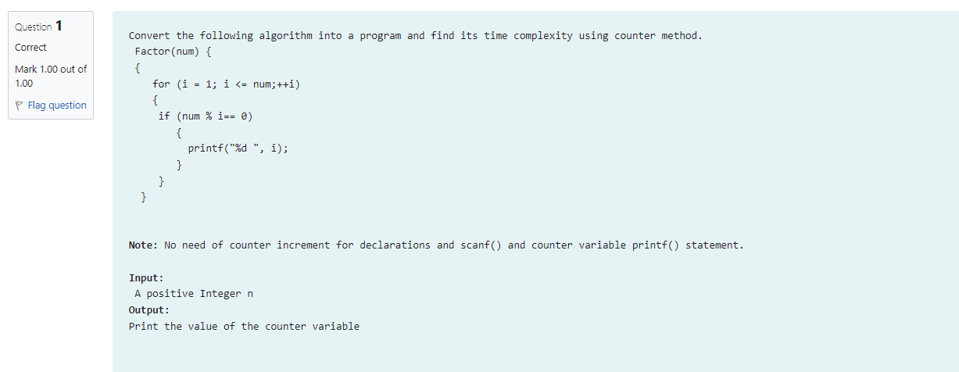

**CODEBottom of Form**

#include<stdio.h>

int main(){

int num,count=0;

scanf("%d",&num);

for(int i = 1;i <= num;++i){

count++;

count++;

if(num% i==0){

count++;

}

}

count++;

printf("%d",count);

}

**OUTPUT**

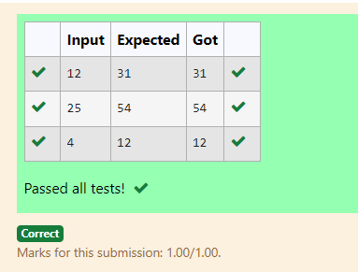

**Problem 4: Finding Complexity using Counter Method**

**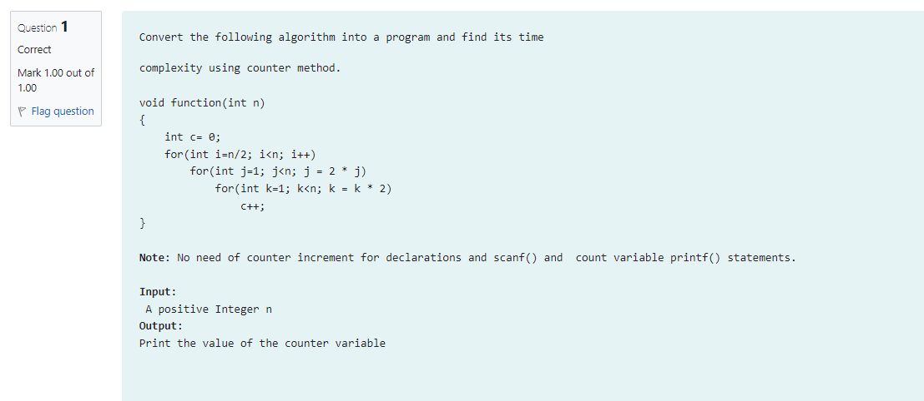  
CODE**

#include<stdio.h>

int main(){

int n,count=0;

scanf("%d",&n);

int c= 0;

count++;

for(int i=n/2; i<n; i++)

{

count++;

for(int j=1; j<n; j = 2 * j)

{

count++;

for(int k=1; k<n; k = k * 2)

{

count++;

c++;

count++;

}

count++;

}

count++;

}

count++;

printf("%d",count);

}

**OUTPUT**

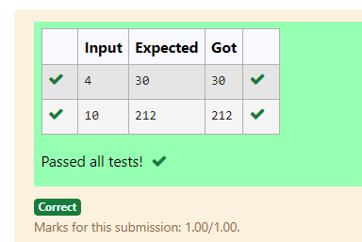

## Problem 5: Finding Complexity using counter method

## 

## CODE

#include<stdio.h>

int main(){

int n,rev = 0,count=0,remainder;

count++;

scanf("%d",&n);

while (n != 0)

{

count++;

remainder = n % 10;

count++;

rev = rev * 10 + remainder;

count++;

n/= 10;

count++;

}

count++;

count++;

printf("%d",count);

}

**OUTPUT**

